- Politics
- Media
- Dharma
- Law & Policy
- Crime
- History
- Others

- Hindi
- Daan & Sewa
- Misc.

- Donate
Top of Form
Bottom of Form

HinduPost is the voice of Hindus. Support us. Protect Dharma
GIVE
-2.1 C
Badrinath
HINDU POST
Saturday, December 16, 2023
Top of Form
Bottom of Form

POLITICS

MEDIA

DHARMA

LAW & POLICY

CRIME

HISTORY

OTHERS

HINDI

DAAN & SEWA

MISC.

DONATE

POLITICS

MEDIA

DHARMA

LAW & POLICY

CRIME

HISTORY

OTHERS

HINDI

DAAN & SEWA

MISC.

DONATE

TERRORISM

A tale of 2 ‘Activists’: The story of ISIS ‘activist’ Saqib Nachan and Khalistani ‘activist’ Bhajan Bhinder
December 15, 2023

Web Desk
(Image Source : The Indian Express)

An ISIS module was busted by the NIA, headed by Saquib Nachan. Many would not know that Saquib goes back to the 1990s with Human rights ‘activist’ Bhajan Bhinder. A trans-national – trans-generational strategy of bleeding India by thousand cuts.
A Thread:
The two ‘activists’ – ISIS fame Saquib Nachan & #OFMI fame Bhajan started together in 1992, & have been working on a two-pronged Hybrid-Warfare against India – spanning three continents and four decades.
On Dec 10, 2023, NIA busted an #ISIS terror module of Saqib Nachan, and while his involvement in the 2002-03 Mumbai terror blasts is well known, he was also instrumental in a foiled terror attack in July 1992, identical to the deadly 93’ blasts, a year earlier.

Saquib Nachan along with Lal Singh, and other ISI & Kh@listani operatives were arrested in 1992 & convicted in 1997 for conspiracy to carry out a series of blasts across India, similar to subsequent 1993 terr0r attacks.
This terror plot was launched under Operation K-2 (Kashmir-Kh@listan) conceived in the 1980s by Pak’s ISI & then Jamaat-e-Islami Press Secretary Amir Ul Azeem, of which Lal Singh, Saqib Nachan, & Bhajan Singh Bhinder became part of, & handled by ISI Col.
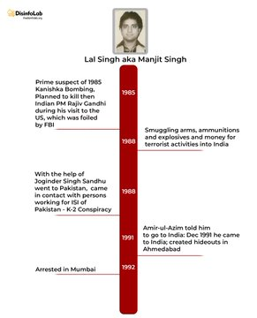
Hafeez-ur-Rehman Lal Singh was team lead for the 1992 terr0r plot, Saquib was responsible for logistics, ISI operative Md Sharief was liaison with ISI & Bhajan Bhinder looked after sourcing funds & weapons for the attack, being based in the US. He was also President of Sikh Youth of America.
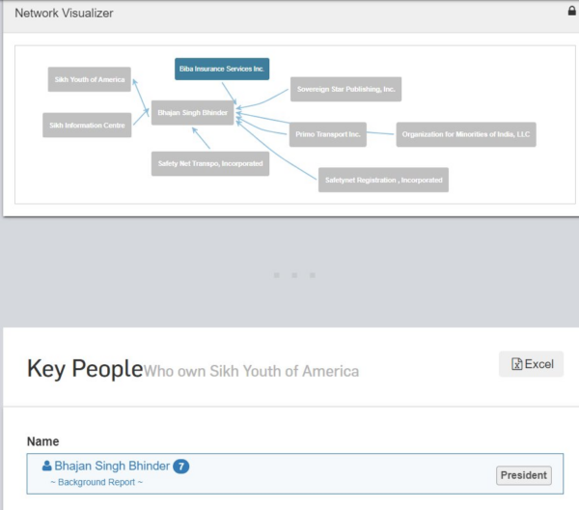
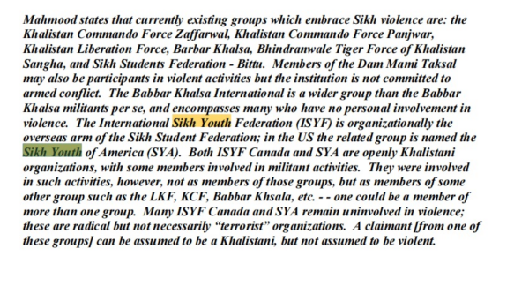
Saquib Nachan, hailing from Borivali Padgha (Maharashtra), was a SIMI ‘activist’. He, along with another SIMI ‘activist’ CAM Bashir were radicalizing and recruiting young unsuspecting minority youth, and sending them to Pakistan for training in arms & explosives.
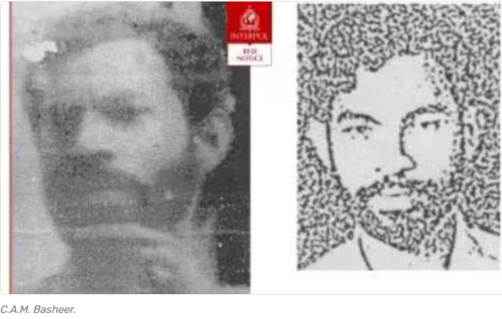
Lal Singh was a member of the radical Khalistani outfit International Sikh Youth Federation (ISYF), and was earlier operating in the US & Canada before coming to India. He was a prime suspect in the 1985 Air India Jumbo Kanishka bombing that killed 329 passengers on board.

The same year, in 1985, Lal Singh was hatching another plot- to assassinate the Indian PM Rajiv Gandhi during his visit to the US. And to assassinate Bhajan Lal, Haryana CM who was traveling to the US.
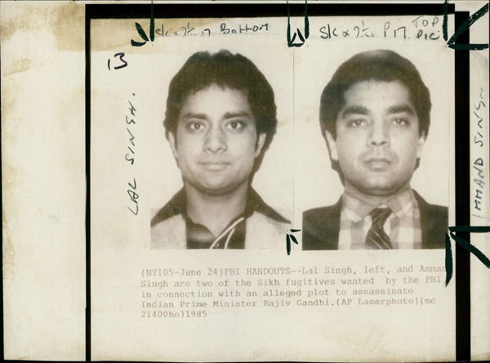
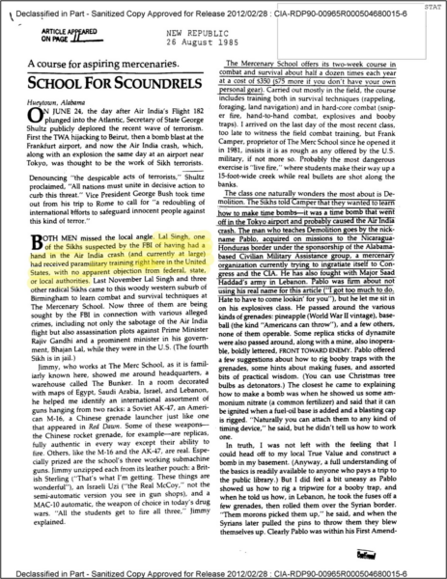
To carry out assassinations & terror attacks, Lal Singh & Co received training in arms & explosives at a ‘Mercenary School’ run in Birmingham, Alabama by US Army Veteran Frank Camper (an FBI ‘Informant’) Plan to kill the PM was thwarted by FBI; PM’s visit was called off.

PM Rajiv Gandhi found it incredible that US permitted such training to Sikh terrorists on its soil; & Indian Foreign Minister,who was seeking action,found US attitude ‘deplorable & disappointing’. In diplomatic parlance, they accused US of harbouring terrorists. Déjà vu!
And while FBI thwarted the terror plot, for which an FBI informant was giving training to the terrorists, some terrorists themselves miraculously disappeared after getting trained! The FBI earned accolades for thwarting the plot, & a Hollywood movie might be on the way.
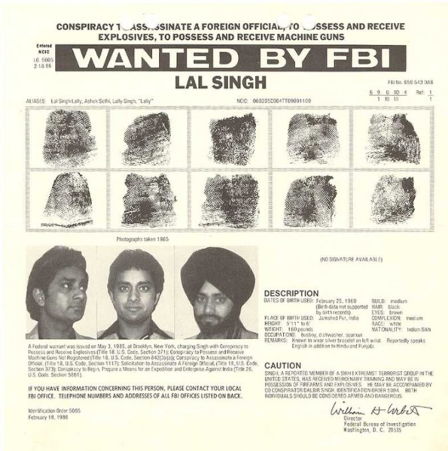
Equally miraculously Lal Singh appears in Pakistan few years later, & reached India in 1991 to carry out terror attacks & assassination, with exactly same kind of weapons & explosives, in which he was trained. The weapons & explosives were caught by police, & plot foiled

Arms & explosives to be used for terror attacks were routed to India via Pak, ostensibly funded by Khalistanis from Canada, US, & UK thru hawala by Satinder Pal Gill (Canada), Mahal Singh Babbars (UK) & most notably, Bhajan Singh Bhinder aka Iqbal Choudhary (USA).

Apart from arranging funds, Bhinder was also scurrying the US black markets for weapons to be sent to India for Lal Singh, Saqib Nachan, and the company. Bhinder was looking for the same weapons in which Lal Singh was trained including C-4 plastic explosives.

Searching for weapons, Bhinder fell into the ‘trap’ of US Customs undercover, who were also investigating the drug cartels being run by Truckers between the US & Canada. Coincidentally, Bhinder was also an ‘activist’ in the field of drug smuggling.

Just before the Agents, posing as weapons dealer, were to arrest Bhinder,he was tipped off by some ‘insider’, likely from one of US agencies.Bhinder aborted the deal saying, he got a ‘funny feeling’. Yet, same types of weapons reached Lal Singh & Nachan in India via Pak.

Lal Singh was arrested in 1992 and was imprisoned for 28 years for plotting terror attacks & waging war against the Indian state. Other accused, Md Sharief and Saquib Nachan were also sentenced to 10 years in jail following the Supreme Court judgement.
From here, paths of 2 ‘activists’ parted After Lal Singh & Nachan got arrested, Bhinder shifted focus to a new form of activism– human rights. In 2007 he formed ‘Organizations for Minorities of India’ (!!!) under leadership of ‘author, activist, expert’ Pieter Friedrich.
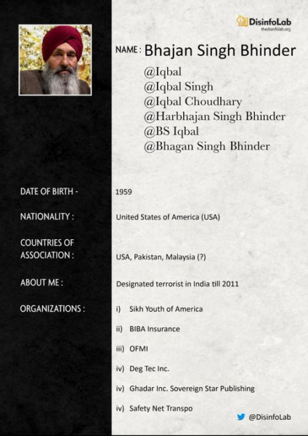
Bhinder-Pieter opened multiple fronts- from transport companies to publishing houses & ‘co-authored’ many books. Most of these companies were fronts for various activities, opened in the name of Pieter & later taken over by Bhinder around 2011.

Meanwhile, acquitted in 2001, Saquib resumed his activism, committing murders and blasts in Mumbai in 2002-03. He was again arrested, and sentenced to 10 years in jail. He was acquitted in 2012, but again arrested for murder, and released on bail in 2014.
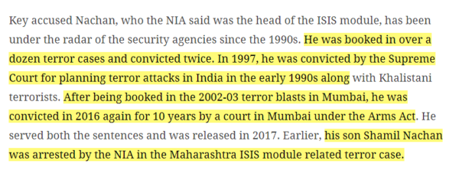


Tale of 2 activism: Pals Bhinder & Nachan, while walking diff. paths of activism, were infact working in tandem–part of much larger & sinister design Nachan was ground operative, working to radicalise & recruit. Bhinder’s ‘rights’ activism gives material for narratives.
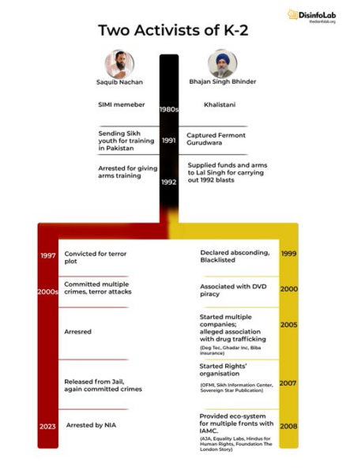
A vicious cycle: The ‘minority persecution’ narrative from these international ‘rights groups’ (of Bhinders) is used to sow alienation amongst minority youth, which is then perpetuated by ground operatives (Nachans) to radicalize and recruit.
Radicalized elements then are used to carry out acts in name of religion or identity aimed at instigating larger society. Reactions, at times irrational, are then used as ‘evidence’ by ‘rights groups’ to produce more atrocity literature, which in turn… (cycle continues)
Bhinder’s OFMI in collaboration with Jamaat fronts in the US – IAMC & JFA created a multitude of fronts – all operating on Indian fault lines.

Some samples:
Dalit Rights org Equality Labs not only credited Bhinder & OFMI (later deleted), but its mentor Huma Dar (d/o Pak Army Col. Bashiruddin Ahmed) is one of the key proponents of K2 design. Her daughter, Natasha Dar is co-author of EL’s rigged Caste report.
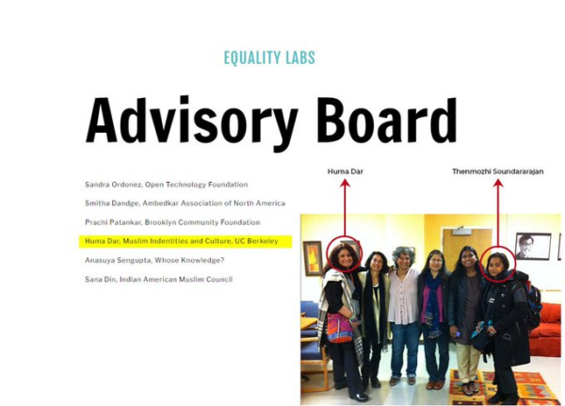
Fronts like HfHR & FTLS– who keep harping about the ‘impending genocide of Muslims’ in India mushroomed under the activism banner of OFMI & IAMC.Sunita Vishwanath’s HfHR’ predecessor– Alliance for Justice & Accountability(AJA) was literally a joint venture of OFMI & IAMC!

They operate by cherry-picking incidents, communalizing events, fake news, and fabricated data to continuously paint an alarming picture – poisoning young minds. IAMC was slapped UAPA for ‘fomenting communal disharmony through fake news’.
Best example of fabrication of atrocities on minorities was DoTo, which closed after we exposed it. But DoTo data had already seeped into various narratives including WaPo etc. And the FIRST persecuted ‘victim’ documented by DoTo? Saquib Nachan! Can’t make this stuff up.
Each of these narratives is built on fake news and fake campaigns- Islamophobia, by ISPR fake handles during Covid, fascism narrative by Pak PM ImranKhan duly echoed by Pieter’s campaign, and recently genocide narrative by Muslim Brotherhood and IAMC/HfHR/TFLS etc.
These organizations and activists collectively worry about secularism, fascism, and genocide in India. They organize conferences & seminars, and write Op-eds based on these ‘databases’ and ‘evidences’.
These, in turn, generate news stories, which in turn are used by ‘activists’ to influence international organizations like USCIRF, which in turn used by ‘international organizations’ to rate India on democracy, freedom of speech and minority rights!
Not surprising that these narratives are seasonal, pushed in coordination by same set of players associated with the fronts, and hyped through a combination of Pak 5th Gen warriors, bots and well-meaning Indians, influenced by the persistent into the info-war.

Each of the campaigns – from fake Islamophobiato coordinated fascism campaign to atrocity database – of them is exposed, sometimes repeatedly. And yet, the narratives stay.
(Lab reports: Unending War-I & Anatomy of 5th Gen Warfare)


These narratives are essential. These narratives by ‘rights activists’ provide a lifeline for ground ‘activists’ like Saqib Nachan to radicalize and recruit. You may be wondering how engineers and doctors have been arrested in the ISIS module of Saquib Nachan.
For details on these fronts and masterminds, pls read our report series: Unending War, published in 2020.

(This article has been compiled from the tweet thread posted by @DisinfoLab on December 13, 2023, with minor edits to improve readability and conform to HinduPost style guide)
Subscribe to our channels on Telegram & YouTube. Follow us on Twitter and Facebook
Liked It?
Support Hindupost

Share

Related Articles

Bharatiya Parliament attack 2023 and the woke toolkit of Inqilab

In the context of the violence directed ideologies, decades of injecting higher doses over time leads to mutation in the evolution of thought processes and resilience of mind while coping with changing situations. This is frame shift.
“We must learn to live together as brothers or perish together as fools.”
MARTIN LUTHER KING

Buddha Quotes

Information about Buddha
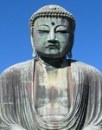
Buddha
Buddha was born into a luxurious life as an Indian prince. His name means "the Awakened One," and he eventually became the originator of Buddhism. At age 29 he began his search for the cure of humanity's sorrow through peace and harmony with everything and everyone. His concept of karma, that what we put into the universe comes back to us, is a fundamental teaching of Buddhism that is still well-known today. He is said to have attained enlightenment during long meditation under a Bodhi tree, at which point he became Buddha until the age of … read more.
Date of Birth: Dec 02, 0

Found 220 quotes by Buddha .
[ Page 1 of 15 ]
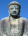
"The whole secret of existence is to have no fear. Never fear what will become of you, depend on no one. Only the moment you reject all help you are freed."
Buddha

"You yourself, as much as anybody in the entire universe, deserve your love and affection."
Buddha

"Your work is to discover your world and then with all your heart give yourself to it."
Buddha

Fav
As quoted in The Problem ehind All ProblemsTop of Form

Bottom of Form

"Peace comes from within. Do not seek it without."
Buddha

"Our sorrows and wounds are healed only when we touch them with compassion."
Buddha
"Neither fire nor wind, birth nor death can erase our good deeds"
Buddha
The Most Brilliant Thoughts of All Time (In Two Lines or Less) by John M. Shanahan
All things appear and disappear because of the concurrence of causes and conditions. Nothing ever exists entirely alone; everything is in relation to everything else."
"You will not be punished for your anger, you will be punished by your anger."

The Way It Is by Ajahn Sumedho
Schism is created on the following premise Shoonyavaad and Brahman
Caste- gotras
Hindu view of Hell and heaven
People create hell and heaven in their own mind through their actions and reactions. Mind plays a great role in creating the image of reality in the consciousness of a person. If the mind is under control, it creates peace within; if it is in an agitated state, it makes life chaotic.
Thus, Shri Krishna says that the mind is its own friend and its own enemy.
What keeps the mind in agitation?
The simple answer is desires. When the desires are fulfilled, they give birth to more desires, when they are not, they cause frustration. Either way, they cause mind to be restless.
In other words, our mind, our unrealistic desires and our attachment to material things create hell for us. We live in that hell. If we live a disciplined life and control our mind and senses through yoga and knowledge, we live in heaven. Contentment and happiness is bliss and that is our heaven. According to Carl Sagan, a noted astro-physicist, all other places such as Jupiter and Mars are hells because no life can survive on any of these planets. Earth is the only heaven if we make it peaceful and sustain it, respect its ecology and try to preserve its beauty.
Hindus have always emphasized these ideas.
Hindus may equate heaven as Devaloka but they do not have a symbol for hell. The word Tamasdwar does not have a symbol

Tibetan view of heaven and Hell

that Ananda should take refuge in `truth' only, knowing it is an island whereby completely contradicting the infinite nature of God in Hinduism??
Three loka vs 7000
Europe’s discovery of the world
Rakat Behta hai
Adaptation and pluralism have caused Eurocentric, Hindu centric and Chinese centric version
PhD thesis becomes the sacred domain and assumptions and theories sacrosanct

Anand Sharan
Mahavakya
He followed the patterns of discourse tradition in Vedic Dharma
Lectures Compilation of Thannisar
Schism starts with socio-political change
Illusion if not destroyed becomes a reality of conflict and confrontation
In the encounter with the world Religions
Abstract
The Illusion of Schism vs. the Inherent Harmony between Dhamma and Dharma
By Kamlesh Kapur
Within Hindu faith and Vedic traditions, a great many philosophic discourses took place. Many saints not only tried to explain the mysteries surrounding the nature of the Divine and the universes He created, they also focused on path to liberation and enlightenment. As a part of this ongoing process, about 2500 years back, two new faith traditions emerged. One of them came to be known as Buddha dharma.
This paper will explain the historical background of Lord Buddha and the socio- Dharmik factors which resulted in the new ways of seeking self-realization, Jivanonmukti and enlightenment. It will also emphasize the parallels in the Vedic Dharma and the Vedic traditions with actual examples from Buddhist tradition of various countries. The paper will explain how and why despite great overlap in the two traditions- both equally vital and direct, in the encounter with the world religions, a vast schism is created deliberately. What were the geo-political forces and what was the agenda of the scholars to create discord and the perception that one is a reform movement of the earlier philosophy. New words were coined such as Brahmanical and assertion were and are being made that the alleged rejection of Brahmanical rituals and sources of knowledge was to be a key feature of Buddha’s life and teachings throughout, just as it was to be a feature of Jainism. In this process, even Buddha’s birth and Hindu roots are displaced in countries other than India.
The current understanding of Buddha Dharma points out significant differences (ephemeral) in Dharma- Dhamma and propagates that, “The Buddha rejected the cosmological framework of the Vedic religion, and its practice of ritual sacrifice. Buddhist religion does not have priesthood in the same manner that Hinduism does. Most important of all, the Buddha rejected the notion of a permanent soul (atman) as well as an Oversoul (Brahman) that lies at the heart of Hinduism. As a result, Buddha’s teaching on karma differs significantly from Hinduism which believes in a permanent soul reincarnating in different bodies. The Buddha taught “rebirth” which said all actions have results; wholesome actions bring wholesome results and happiness; unwholesome actions bring suffering and unhappiness. Thus, the Buddhist idea of rebirth is delinked from a belief in soul or atman.” Opposition to such Eurocentric views is berated with the accusation that placing Buddha Dharma and its roots in Hindu nation and millennia old philosophy is Hindu-centric view. Highlights of both Dharma and Dhamma are digested by assorted group of doctors, media and academia creating a very dangerous situation. Through an analytical discussion of the psychological and philosophic parallels in the two most ancient traditions, an attempt is made to clear myths and demolish mountains of ignorance.
The seasons would synchronize better with the tropical year but NOT for subtle effects such as any pattern in the weather which are dependent upon gravitational pull of other heavenly bodies such as the Moon and the Sun - for example - the tides (high or low). This is because these events happen based on the centre of gravity (position) of the planets in sky. The tropical year is dependent upon the orientation of the sun's rays on the earth's curved surface.
Most of India did not have this tropical-sidereal problem to deal with because the real pundits knew about precession since ancient times and our model of Bramhand did not have all celestial bodies moving around the earth. We followed luni-solar calendar and we were used to celebrating our festivals on varying tropical days.
It is the Xtian church which had to have simplistic rules for everything and that has resulted into this tropical year whereas India was used to variability of seasons and festivals. Anand Saran- July 2012
In the encounter with the world Religions
Within Hindu faith and Vedic traditions, a great many philosophic discourses took place. Many saints not only tried to explain the mysteries surrounding the nature of the Divine and the universes He created, they also focused on path to liberation and enlightenment. As a part of this ongoing process, about 2500 years back, two new faith traditions emerged. One of them came to be known as Buddha dharma.
Buddha- Sanskrit word, literally means the enlightened one and his mission was to find a path of Moksha or Nirvana- both are Sanskrit words and are in a way synonyms

Historical background
Siddhartha later known as Gautama Buddha was born in the 6th century B.C in Lumbini- now in Nepal. He was the son of King Sudhodana- the Hindu King of Kapilavastu. Kapilavastu was a part of the then Magadha Empire. It is believed that Siddhartha belonged to the solar dynasty, one of the most ancient dynasties. Rama, the king of Ayodhya also belonged to this dynasty. Queen Maya- Gautama’s mother died shortly after his birth.
It is said that at the time of Gautama’s birth, the royal astrologer of the kingdom predicted that the boy Siddhartha (the given name of Gautama) would be the greatest saint of the century and he would renounce the world. The King did not want this type of life for the Prince; therefore, he tried to surround the young prince with all kinds of luxuries and pleasures. Siddhartha got married at a young age and his father kept him surrounded with worldly comforts and enjoyments. Siddhartha was not allowed to step outside the palace compound.

Siddhartha’s encounter with the real world

One day, the young prince wandered out of his palace and was deeply distressed by the sufferings and miseries of the people he saw. He tried to find reasons for the unhappiness of mankind. No one could provide him with adequate answers and Siddhartha became obsessed with the causes of endless cycles of birth, growth, decay and death, entailing more and more misery. He realized that he could not find answers without renouncing the world and the royal duties. He left his wife Yashodhra and his son- Rahul to start his spiritual journey.

The path of self-realization and enlightenment
Many recent historians believe that Siddhartha was not raised in seclusion. He left his home in order to look for places of higher learning. The names of his gurus also suggest that he did gain spiritual knowledge under the teachers – one of them being- Udaraka. His quest was to find ways to attain Moksha and liberation from suffering. The answers did not come. Then he sat under the Bodhi tree- a sacred fig (Ficus religiosa) with the firm determination not to move until he attained absolute truth. Many Buddhists believe that his search for the truth was obstructed by demons. One of the demons was Mara. Mara may be associated with the Hindu concept of Maya (illusion). It is pertinent to point out that Hindus also believe that on the path of enlightenment, one encounters Vrittyas (literally meaning serpents).
Many revelations came to him through his austere meditation. He got the vision the very first day but kept sitting for the next seven days, enjoying the blissful state of emancipation from desires. At first, Buddha was reluctant to teach, because what he had realized could not be communicated in words. Only through Yogic discipline and clarity of mind one could have direct experience of the Great Reality. Buddha believed that the listeners without that direct experience would be stuck in conceptualizations and may misunderstand everything he said. But compassion persuaded him to make the attempt. After his enlightenment, he went to the Deer Park in Isipatana, located in what is now the state of Uttar Pradesh, India. There he found the five companions who had abandoned him earlier.
The seeker of truth then decided to propagate his ideas to the world. His five companions were his first disciples. From then on, he continued to live the life of a hermit. Gautama and his disciples begged for their food and did not engage in any activity involving earning money or creating desires. Bhikkus or Bhikshus- disciples of Buddha who begged for sustenance and at the same time followed and propagated Buddhist tenets.
Wandering through many cities and kingdoms, one day he stood in front of a door that was opened by his wife with a bowl of food. Even today, it is customary in India to open the door with a bowl of food, expecting a wandering hermit begging for food. Gautama was a bhikshu at that time. She gave him food. Their eyes met for a moment and then he was gone. It needs to be emphasized that both words- Bhikkus and Bhikshus are Sanskrit words.

Teachings of Buddha

The first sermon was delivered by Gautama in the Deer Park in Sarnath to his five disciples. This sermon has been preserved as the Dhammacakkappavattana Sutta and centers on the Four Noble Truths. Instead of teaching doctrines about enlightenment, Buddha chose to prescribe a path of practice through which people can realize enlightenment for themselves and avoid suffering.
In that sermon, he argued about the futility of elaborate religious ceremonies that common people did not understand as also the danger of overindulgence in sensual pleasures. He condemned both extremes of austerities and overindulgence in pleasures. He advocated the middle path, which he called the path of eightfold virtue. These virtues are listed under three headings:
Training for attainment of wisdom
Right views,
Right intentions and resolve

Training for moral behavior (ethics)
Right speech,
Right action,
Right living
Training for meditation
Right effort,
Right recollection and,
Right meditation
For the next forty-five years, he moved around, preaching the middle path as a way of liberation from human misery and sorrow and be able to attain Nirvana (Sanskrit word for liberation and synonymous with Moksha). Buddha stressed Nirvana as the ultimate goal of life and eightfold path as the means of achieving it.

Three wheels of Dharma?
The wheel of Dharma symbolizes spiritual journey of a person. As the wheel turns, through one’s Karma, a person finds himself closer to the Divine. One needs to improve one’s karmas by following the middle path and observing the principles laid down by Buddhists.

Four noble truths

Buddha realized that life is difficult. Life is difficult because of attachment we have for worldly things and the relations we build. Liberation is possible for all of us. The way to avoid suffering is to lead a compassionate life of virtue, wisdom and meditation.
THUS, has it been said by the Buddha, the Enlightened One: It is through not understanding, not realizing four things, that I, Disciples, as well as you, had to wander so long through this round of rebirths. And what are these four things? They are the Noble Truth of Suffering, the Noble Truth of the Origin of Suffering, the Noble Truth of the Extinction of Suffering, the Noble Truth of the Path that leads to the Extinction of Suffering.
The path of purification, morality, renunciation, and restraints such as nonviolence are the way to liberation from suffering and anguish.
Drawing conclusions from these aspects of cosmic reality, modern day psychologists continue to tailor their therapy they give to their patients.
At philosophical level (in Vedanta) at practical/medical level, Hindus always believed that pain indicates some ailment or malfunctioning of the body; however, the suffering is felt by the mind.

Niyamas- (laws) and Nyaya (justice and balance) both are Sanskrit words.
There are five Niyamas:
1. Utu Niyama (material nature)- law of physical matter (that of physics and chemistry)
2. Bija Niyama - law of living matter (that of life science)
3. Kamma Niyama (Kama) - law of karma, activity and transformation
4. Dhamma (dharma) Niyama - law of natural phenomenon on spiritual level (such as occurrence during Buddha's birth, gaining of enlightenment and passing away)
5. Citta Niyama (Chita) - law governing consciousness (that of psychology)
Buddha’s last Words
The Buddha tirelessly traveled and taught until his death at age 80. His last words to his followers were, "Behold, O monks, this is my last advice to you. All component things in the world are changeable. They are not lasting. Work hard to gain your own path of Nirvana."
Religious practices and beliefs

New words:
Bodhisattvas- the saints, Lamas and high priests of Buddhists
Buddhists believe in reincarnation. Therefore, they strongly believe in austerities and good deeds. Following the right path, they believe that they will either attain Nirvana or get a better life after death.
Many Buddhists believe that constellations of planets and moon affect the environment and have a profound effect on humans as well. They have reverence for nature.
They respect elders and follow the advice of Gurus (Lamas, Bodhisattvas, high priests, and other elders.
They cremate the dead bodies.
They believe that prayers can ward of evils and obstacles. Often, they pledge to light lamps around the monastery if they come back from a pilgrimage or achieve success in their endeavor. They believe that there are Devies who preside over the mountains and protect the people.
Buddhists from Tibet, Nepal and eastern Himalayan regions offer elaborate prayers in front of the statues of Buddha and other Bodhisattvas. Monasteries and temples have gilded figures of Buddha and Bodhisattvas. For Hindus and Buddhists, symbols provide a focus for prayers
For example, the Sherpas of Nepal and Eastern Himalayan states enter the main part of the monasteries, prostrate three times before the Buddha and other Bodhisattvas. They light the butter lamps.
Just as Hindus do, they offer fruit, other types of food, cloth, flowers, and money to Buddha. A part of the fruit is returned by the presiding monk/priest as a token of blessings- much the same way as is done in the Hindu temples.
Thus, Buddhist like the Hindus believe in karma, reincarnation, yoga, meditation, simple living, fasting for cleansing, prostrating in front of Vigrahas and lighting the lamp at home and in the monasteries. They also generally cremate their dead. Because of these similarities with Hindu Dharma, after the start of Mahayana Buddha Dharma, Hindus started considering him as the ninth incarnation of the Divine. For these and other reasons, Buddhism almost disappeared in India. The constitution of India considers Buddhists as Hindus; so does the Supreme Court of India for the purpose of application of civil law.

Way of Life, Family Values
Nonviolence, tolerance, respect for elders, reverence for nature, simple life and austere discipline characterize Buddhist values. Some of the noblest Vedic aspirations are enshrined in Buddhist spirituality and the way of life. Buddhists want inner peace and they reach out to others for peace and friendship. They value their own freedoms for spiritual efforts and they try for others to have the same.

Impact of Buddha’s teachings and the Spread of Buddhism to other countries
Even during his lifetime, Buddha Dhamma spread like a forest flame. He simplified Vedic Dharma, so that common people could understand and practice it. His qualities of humility and compassion won him a following of thousands of people. The simple ideas of ethics and self-restraint of Buddhism were so appealing that over the centuries it spread to several countries outside the land of its birth, such as Ceylon (Sri Lanka), China, Japan, Cambodia, Burma, Thailand, Indonesia, Tibet and several other East Indian Islands. People of all races and countries embraced it. Religious messengers from foreign countries came to acquire Buddhist ideas and attain practical wisdom about life and its goals. The most notable visitors were Fa-hiang, fifth century A.D. and Hiuen-tsang, seventh century A.D. These emissaries not only carried with them Buddhist religion but also the ideas of Indian culture and the glory of Indian civilization. Their accounts are considered some of the earliest historical documents quoted in various history books. Even now, based on the number of people following it, it is the fourth largest religion of the world and has been a source of inspiration to the intellectuals and practical psychologists. For curing mental problems, today the psychologists use these techniques of introspection, self-realization, and meditation and Yogic discipline. Dalai Lama, the exiled leader of Tibet is the religious head of Tibetan Buddhism and has been continuously working for world peace through nonviolence and inner harmony.
Starting with Mourya and Kushana kings, several Viharas were built. The old renowned universities such as Takshashila in Gandhara (modern day Afghanistan) for general education and Vedic philosophy now included studies in Buddhist philosophy. King Kumar Gupta of Gupta dynasty started what became the greatest university of ancient India. This was Nalanda University in Bihar. The famous Chinese traveler, Hieun-Tsang studied there for two years.

Unity and diversity in Buddhism- Divergent traditions
Buddha’s followers did not think of him as God. Down the centuries, 3 main sects emerged. Buddhists of Hinayana tradition considered him as the enlightened one. The followers of Mahayana tradition considered him as God and created a prior incarnation of Buddha. This sect started making temples. Viharas or the residential places for the monks and other disciples were adjacent to the temples. The prayer hall was called Chaityas. There were caves for meditation. Most of the temples today have Buddha as well as statues of Bodhisattvas.
The third tradition is Vajrayana. The followers of this sect practice Tantra. They worship symbols, offer prayers to Buddha and the priests. They believe that the blessings from the Lamas and the proper procedures followed by the followers can ward off evils. Buddhists of Tibet, Nepal and Eastern Himalayas follow Vajrayana tradition.

Pluralism inherent in Dharma- Dhamma faith traditions
Pluralism- belief that there is more than one explanation of reality or the divine and there are several ways of worshipping the Divine. Pluralism means that we see the Divine through a prism and through a specific lens alone
Buddhists accept all divergent views. Over 2 and half millennia, Buddhism has touched the lives of billions of people without firing a single shot.
- Spirit of accommodation allowed blending and coexistence
- Diversity of traditions and coexistence of all faith traditions emerged,
- Cultural diffusion took place,
- Borrowing from each other’s daily prayer routines or retaining some of the Vedic practices and beliefs led to the creation of a society where often the rulers were Hindus and the subjects were Jains, Hindus and Buddhists. Many sites of pilgrimage have Buddhist and Hindu temples side by side.
- People were allowed to offer prayers in their regional languages and dialects. With over 2000 dialects and languages in India alone, the same prayers and chants seem different, though they express the same aspiration.
- Buddha Dhamma responded to the changes in culture which in turn were caused by socio-political changes over all these centuries. Diverse practices to accommodate regional diversity and geographical realities of the regions. For example in Japan, without encroaching on the earlier religious practices and philosophy, Buddhism became the mainstream religion of the country.

The role of Sangha and congregation
Sangha has been a platform for discourse and solving problems of individual members.
Buddhism is a secular tradition. It is a non-political path, neither the followers nor the Sangha tried to displace or substitute political institutions. Buddhism as a way of life kept religion and politics separate. Secularism is inbuilt in Buddhism and in its Vedic roots. Tibetan Buddhism is the only exception where the Dalai Lama has been the political, social and religious head of the Tibetan people.

Debates, discourses
Several Buddhist councils were held to allow philosophical debates and to update the rules to be followed by the followers of Buddhism.
In these councils, the teachings of Buddha were discussed, debated and were codified.
The first of these was held soon after Buddha’s Nirvana. In this council, Buddha’s senior disciples systematized his teachings. About one hundred years after Buddha's passing away, the Second Council was held to discuss some Vinaya rules (rules of courtesy and protocol). Even though no controversy about the Dharma was reported, some orthodox monks opposed any changes. It seems even at that time, there was a possibility of a split. All four Dharmas of Indian origin do not mind such splits.
The third council was held around 250 B.C. and the fourth council was held during the reign of Kanishka in 100 A.D. Another Buddhist council was held during the reign of Harshvardhana- 7th century A.D.
Holding public debates is an ancient Vedic practice. It may be noted that the last famous debate chronicled is between Shankaracharya and a Shudra in which the Shudra had won the debate. Acknowledging his defeat, Shankaracharya touched the feet of the Shudra.
Buddhist followed the same tradition.
Although each school of philosophy within Buddhism is unique, they are bound by certain common characteristics like open mindedness, direct experience, support of logic and reasoning. In approach and practice, Buddha Dhamma is an offshoot of Eternal Vedic traditions.
When a follower of one school uses the power of reason to convince another, he has to first listen to another's viewpoint, use his intellect to find fault in that argument and lastly articulate his viewpoint convincingly. To do so a person needs to have an open mind and be a good listener. In India, this attitude led to several debates between Hindus and Buddhist in the first millennia- the most famous being the one between Vedic sages and Huent-sang during the reign of Harsha Vardhana
Did Buddha believe in God? In Vedic traditions, there is freedom to believe in the existence of God or not. Those traditions which believe in God are known as Astika traditions. Those who deny the existence of God are known as Nastikas. Buddha and the followers of Hinayana tradition are silent about God. Many philosophers consider Jain, Buddhists and Charvakas to be non-believers.
Was he God? For several centuries, His followers did not consider him to be God. Many still do not.
Buddha did not question the laws of nature; he only recommended the ways how to be liberated from the suffering caused by the cycle of life and death.
Buddha fully comprehended how the nature worked. The Buddha did not create nature's laws. They existed before Buddha's time and will continue to exist whether or not the Buddha is around. Buddha discovered the laws. So did hundreds of ancient sages and Rishis. Indian philosophy relies on direct vision of truths and pure reasoning.

Bhagvad Gita and the Buddhist teachings
Getting cloth, he uses it not tied to it, uninfatuated, guiltless, seeing the drawbacks (of attachment to it), and discerning the escape from them. He does not, on account of his contentment with any old robe cloth at all, exalt himself or disparage others.
Furthermore, the monk is content with any old almsfood at all. He speaks in praise of being content with any old almsfood at all. He does not, for the sake of almsfood, do anything unseemly or inappropriate. Not getting almsfood, he is not agitated. Getting almsfood, he uses it not tied to it, uninfatuated, guiltless, seeing the drawbacks (of attachment to it), and discerning the escape from them. He does not, on account of his contentment with any old almsfood at all, exalt himself or disparage others. In this he is skillful, energetic, alert, and mindful. This, monks, is said to be a monk standing firm in the ancient, original traditions of the Noble Ones.
Furthermore, the monk is content with any old lodging at all. He speaks in praise of being content with any old lodging at all. He does not, for the sake of lodging, do anything unseemly or inappropriate. Not getting lodging, he is not agitated. Getting lodging, he uses it not tied to it, uninfatuated, guiltless, seeing the drawbacks (of attachment to it), and discerning the escape from them. He does not, on account of his contentment with any old lodging at all, exalt himself or disparage others. In this he is skillful, energetic, alert, and mindful. This, monks, is said to be a monk standing firm in the ancient, original traditions of the Noble Ones.
Furthermore, the monk finds pleasure and delight in developing (skillful mental qualities), finds pleasure and delight in abandoning (unskillful mental qualities). He does not, on account of his pleasure and delight in developing and abandoning, exalt himself or disparage others. In this he is skillful, energetic, alert, and mindful. This, monks, is said to be a monk standing firm in the ancient, original traditions of the Noble Ones.
These are the four traditions of the Noble Ones — original, long-standing, traditional, ancient, unadulterated, unadulterated from the beginning — which are not open to suspicion, will never be open to suspicion, and are unfaulted by knowledgeable contemplatives and brahmans.

The four noble truths and many of the significant ideas in Buddhist thought including the Yoga, nonattachment, karma yoga and meditation are at the core of the Bhagvad Gita. Bhagvad Gita says that desire is the root cause of all suffering. It further expands the sequence of misery thus, desire leads to expectation, when the desires are not fulfilled, and there is frustration and anger, anger clouds judgment which causes the loss of intelligence. When intelligence is lost, everything is lost. Bhagvad Gita advocates discipline (yoga) as applied to devotion, to cognition, knowledge, action, food and almost every aspect of life. However, the historical context of Bhagvad Gita and Buddha’s teachings is different.
Buddhism as compared with Vedic religion
Here this axiom may be emphasized that something does not come out of nothing. Vedic verses and prayers were the result of observation of multifaceted Prakriti, reverence to it and ultimately praying to it. Buddha Dhamma was simplified for common people to avoid suffering.
Dhamma is not different from Vedic Dharma and Buddha never tried to replace it. If some of his tenets seem different, it is because Pali language is used in place of Sanskrit. His eightfold path of virtues is so similar to Manu’s ten principles of righteous action (Dharma das lakshnam) that one can trace his Vedic roots as a Hindu Prince. His ideas on balance in life and Karma seem like coming right out of the Bhagvad Gita. He advocated pilgrimages to the holy places, ceremonies to offer respect to the ancestors, the Yajna ceremonies (called Yonna in Buddhist texts). He shifted emphasis to nonviolence and righteous living. Buddhism was soon accepted and assimilated in Hindu traditions. It did not remain as a religion any different from Hinduism and eventually it disappeared from the land of its birth. At no point in time was there any evidence of intolerance, conflict or persecution between Buddhists and the Hindu population, so much so that in Puranik literature Lord Buddha is accepted as one of the incarnations of God. Many Hindu temples have Vigraha of Buddha along with Hindu Vigrahas of Vishnu, Krishna and Rama.
At many sacred sites, Hindu and Buddhist monasteries exist side by side. For example, Lumbini, the birth place of Buddha is a place of pilgrimage for both Hindus and the Buddhists.
Comparison chart
Hindu Dharma | Buddhism | Jainism
God is one & everywhere | Same | same
All religions lead one to God | Same Same
Through self-realization one can attain self-control and reach Godliness | Same | Same
There is no escaping the consequences of one’s actions. Our Karma follow us and partly determine our destiny | Same, so live simple life and be liberated through Yoga and  meditation
Hindu philosophy has proven itself as eternal leaning on logic and scientific methods of inquiry | As a part of Hinduism, it got merged into Hinduism. However in countries outside India, it retained its original beliefs and rules uniquely adapted to local conditions | Emphasis on  Ahimsa and simple  life, path to self  realization

Vedanta, Upanishads, Gita- Shankracharya
Delinking and isolation of one from the other creates fragmentation of the roots of both faith traditions and weakens them.
Buddhists scattered- not belonging to a Nation, therefore not a threat to the western world
Digestion of Buddhism in psychology, western philosophy
The art of happy living
Steve Jobs
Hindu centric view vs. Eurocentric view
Tibet a case study
Sherpas of Nepal- a case study

Shila or this section of the Eight-fold path, also called Buddhist ethics are often compared to the last five commandments of the Ten Commandments: Right Speech = You shall not bear false witness against your neighbor , and the remaining commandments are included and often explained in commentary in the categories of Right Actions and Right Living: You shall not kill, You shall not commit adultery, You shall not steal, You shall not covet your neighbor's wife , You shall not covet your neighbor’s goods.
Pali- Sanskrit
Misleading generalizations stemming out of Eurocentric- Chinese bias (heavily promoted by media and in educational institutions) have gained authenticity through two centuries of western scholarship.
Examples
There has been a revival of Buddhism in India in the last fifty or sixty years but mainly as a social reform movement that seeks to improve the lot of oppressed minorities.
Instead of teaching doctrines about enlightenment, the Buddha chose to prescribe a path of practice through which people can realize enlightenment for themselves and avoid suffering.

Training or practice necessary for the attainment of wisdom:
(1) Right View or Right Understanding (Sanskrit- samyag-dṛṣṭi / Pali- sammā-diṭṭhi) this can also be translated as "right perspective" or "right outlook" –the practitioner must understand the Four Noble Truths and realize their applicability in his or her life.
(2) Right Intention or Right Resolve (Sanskrit- samyak-saṃkalpa / Pali- sammā sankappa) is also called "right thought", "right conception", "right aspiration" or "the exertion of our own will to change"- the practitioner should constantly aspire to eliminate qualities that are wrong and immoral, right view will help the practitioner to discern the differences between right and wrong.

Training or practice necessary for the attainment of correct moral behavior (or ethical conduct):
(3) Right Speech (Sanskrit- samyag-vāc / Pali- sammā-vācā) – explains the manner in which a Buddhist practitioner should use words, and includes not only abstaining from lying, from divisive or abusive speech, but also cessation of idle chatter… so that your speech is connected to the goal of enlightenment or self-improvement.
(4) Right Action (Sanskrit- samyak-karmānta / Pali- sammā-kammanta) can also be translated as "Right Conduct" wherein the practitioner should train his or herself to be morally upright in all activities, never acting in ways that would be corrupt or bring harm, abstain from taking life, from stealing, from sexual misconduct.
(5) Right Living of Right Livelihood (Sanskrit- samyag-ājīva /Pali- sammā-ājīva) - practitioners should not engage in trades or occupations which result in harm for other living beings. These are five types of businesses that are harmful to undertake are:
1. Business in weapons: trading in all kinds of weapons and instruments for killing.
2. Business in human beings: slave trading, prostitution, or the buying and selling of humans.
3. Business in meat: "meat" refers to the bodies of beings after they are killed. This includes breeding animals for slaughter.
4. Business in intoxicants: manufacturing or selling intoxicating drinks or addictive drugs.
5. Business in poison: producing or trading in any kind of toxic product designed to kill.

Training for meditation, mental discipline - Samādhi, literally translated as "concentration" be achieved by training the mind to attain higher consciousness that will bring calm and composed collectedness which is necessary and essential in order to develop true wisdom by direct experience.

Siddhartha Gautama, later known as Shakyamuni Buddha or Gautama Buddha, was born in the 6th century BCE in Lumbini- now in Nepal. Traditional hagiographical accounts of Buddha’s life claim he was the son of King Sudhodana of the Sakya lineage- the king of Kapilavastu in the foothills of the Himalayas. In this hagiography, Buddha’s mother, Queen Maya, while on her way to her parents' home, gave birth to her son in Lumbini Park, on the full moon in the month of May.
In the last century, many historians of Buddhist tradition discounted many features of this hagiography and created a neo-hagiography. These scholars using myopic Eurocentric view have delinked Dhamma and Dharma in the following ways: Buddha was a tribal, not a Hindu, his father was chief of the tribe and had nothing to do with Indian or Magadha.
His path had nothing to do with Bhagvad Gita or Vedic Traditions.
He revolted against caste system, oppression of women and other minorities. He also preached against the Hindu practice of animal sacrifices and Yajna ceremonies.
Monks are like saints of Christianity who lived as celibates in the monasteries.
Shila (bedrock of Buddhist ethics) is the same as the Ten Commandments. His emphasis on right actions and right living are similar to what Moses said in his sermon (a veiled suggestion that Buddha borrowed from Moses. For example, you shall not bear false witness against your neighbor you shall not kill, you shall not commit adultery, you shall not steal, you shall not covet your neighbor's wife, and you shall not covet your neighbor’s goods.
It may be noted that in order to accommodate these erroneous generalizations they have first altered the chronology of the world history. Moses is shown to exist in 3000 B.C; whereas Buddha’s time frame was 6th century B.C.
They are also using the modern map of India where Nepal is shown outside India. We may check the old map of India and of Bihar:
Looking at the map, the following questions arise:
Was Kapilvastu in Nepal? The boundaries of Uttarpatha were very fluid and with each war or even a tiny battle, it shifted. Was Sakya kingdom a part of the then Magdha Empire? Buddha moved around in modern day Bihar and Madhya Pradesh. Ruling the kingdom, King Sakya was a Hindu and Siddharth was a Hindu prince.

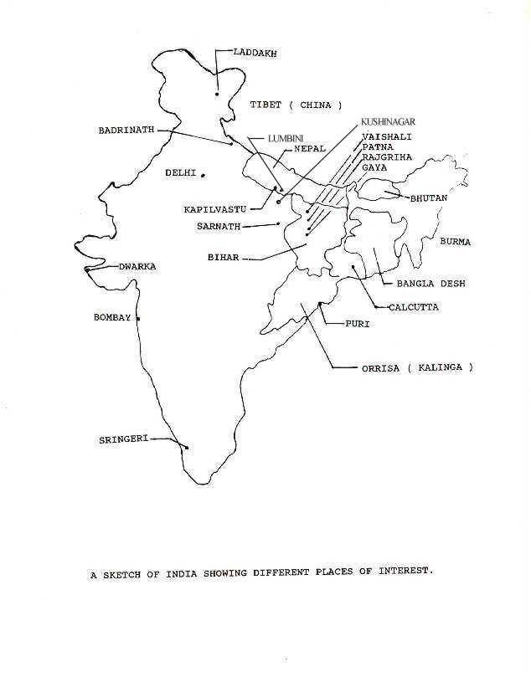


He came to Vaishali and spent some time amongst the Jain monks. He found this life style to be of extreme penance and austerity, so he left the place and went to the Magadha capital called Rajgriha, where King Bimbisar was ruling. Then he continued on beyond the Hindu holy town of Gaya. He crossed the Niranjana (Phalagu) river and entered a forest. He found a group of five wise men in the forest. They practised penance to control suffering. Siddharth practised extreme penance for six years and grew very weak and thin. Nearby the forest, lived Sujata and her husband, a herdsman. She once took a delicious meal called `khir (a kind of pudding)' in the local language into the forest as an offering to the spirits. On seeing Siddharath in meditation, she thought he was the spirit. So she offered him the food which he took. Finally, after some time, he obtained enlightenment under a fig (Pipal) tree.

After his enlightenment, he travelled to Sarnath and gave his first sermon to the wise men who had left him in the forest. He also gave sermons on the Vulture Peak at Rajgriha to King Bimbisar . He went to Vaishali several times, and there he gave a sermon even to Amrapali who was the famous dancer. He accepted her invitation to come to her mango grove. It was not liked by the chiefs of Vaishali. It was here, he allowed women, his foster mother, his wife and Amrapali, etc., to join the Samgham ( Order ) as nuns at the request of his disciple Ananda. He died at Kushinagar close to his place of birth at the age of 80 in the year 483 B.C..

BUDDHA'S LAST WORDS TO HIS DISCIPLE ANANDA

These last words clearly show the difference between Buddhism and Hinduism and are quite famous. These are: "Be island to yourself, Ananda! Be a refuge to yourself; do not take to yourself any other refuge. See truth as an island, see truth as refuge. Do not seek refuge in anyone but yourselves. Have done, Ananda! Do not weep, do not distress yourself! Have I not often told you that it is in the very nature of things that we must eventually be parted from all that is near and dear to us ? For how, Ananda, can it be other wise ? Since everything born evolved, and organized contains within itself the germs of disintegration, how can it be otherwise then that a being should pass away ? No other condition is possible !

For long you, Ananda, have been very near to me by acts of devotion, faithfulness and affectionate, ever loyal beyond all reckoning."

As mentioned earlier, Lord Buddha went to Sarnath to give his first sermon to the wise men. Sarnath was near the holy city of Varanasi and within the Koshal Kingdom.

Lord Buddha's idols were not used until 400 to 500 years after his death. There were only stupas (topes) built in his memory which was in practice in Jainism before Lord Buddha's time. Another symbol that was used by his followers was a wheel called `Dharma Chakra'. It has eight spokes out of which four are thick. The thick ones represent the noble truths whereas the eight of them combined represent the paths.

BUDDHISM AND GOD

Lord Buddha denied the existence of both the Dynamic God as well as the Atman as the Individualized Soul, which were respectively, the concepts of Truth in Hinduism and Jainism. This is also known as the Sunyavaada. His thinking is quite clear in his last words to Ananda where he mentions that the germs of disintegration are existent in our bodies and that Ananda should take refuge in `truth' only, knowing it is an island whereby completely contradicting the infinite nature of God in Hinduism. Challenge it

He was against animal sacrifice and untouchability practised by the Hindus. He took the middle path between Hinduism and Jainism. The Jains saw life in practically everything, so they practised extreme form of non-violence, on the other hand the Hindus used animal sacrifice and were quite violent in relative terms. Lord Buddha did eat meat but only if the animal was not killed for him. He did emphasize non-violence, but not to the extent done in Jainism.

After Lord Buddha's death, the first Buddhist Conference was held at Vaishali in year 383 B.C. and the second one took place at the Ashoka's capital, Pataliputra, in the year 247 B.C. He erected several pillars, with edits at several places within his kingdom. He built monasteries and stupas (topes) because idols of Lord Buddha were not worshipped during his time. It is worth mentioning here that (a) the rise of Mahayana sect in this religion started in the second century B.C.. Before this, there was only Hinayana sect, and no image of Lord Buddha was used for worshipping during those years.

HINDUISM, BUDDHISM AND JAINISM

If the mental qualities of the sthitaprajna of Gita and Arhat of Buddhism are compared, we would find a great deal of similarities between the two. The qualities of the two namely: (a) peaceful, (b) desireless, (c) mindless, (d) equal in pain or happiness etc., are the same. In fact, the 20 values mentioned in the Gita discussed earlier, are more or less same as the Eight Fold Path mentioned in Buddhism. There are statements in the Buddhistic religious treaties that Gautama Buddha had personal discussions and conversations with highly moral brahmins, and bearded ascetics who were well versed in the Vedas and other Vedic literature.

If we compare the Buddha's preachings and the Path of Renunciation where it believed that all the activities in this world produce `desire' which in turn leads to unhappiness as mentioned in the Second Chapter of the Gita, it is quite clear that both concepts are almost identical.

However, he said that (a) as a result of casualty, the body which is defined by Name and Form, has to take birth again and again in this perishable world, and (2) this worldly life is full of unhappiness and it is necessary to acquire permanent peace. These two views are identical in the Vedic religion.

Long after Buddha, the Mahayana sect started worshipping him which was similar to the Vedic Path of Devotion. They even preached that attaining nirvana (liberation) was only his pastime and that he (Buddha) is eternal or can never be destroyed. In some of the Buddhistic treaties, it was preached that the true Buddha was the father of the world and people are his children, a statement possibly derived from the Gita, where Lord Krishna says that he is the father and from his seeds in Hiranyagarha, all the creation (Shristi) has come about.

There are many other similarities. Practically, the Jainism and Vedic religions grew or evolved side by side for many centuries and people changed faiths or never knew the difference between the two on most of the occasions.

“Hindus and Buddhists, we are two sons of the same mother.” So said Dalai Lama.
“India was……. Mother through Buddha of the ideals embodied in Christianity..”
Will Durant- ‘The Story of Civilization’ vol. 1
Encounter with three persons from American academia
Two PhD in Education,
One in Buddhist architecture
Their perspective
MV
Mahavagga (MV)- FIRST KHANDHAKA.- The Admission to the Order of Bhikshus
It is very frequently stated that there are three samkhâras or productions: kâyasamkhâra, vakisamkhâra, and kittasamkhâra, or, productions of body, of speech, and of thought (see, for instance, the Sammâditthisuttanta, Magghima-Nikâya, fol. khû of Turnour's MS.) The kâyasamkhâra consists, according to the Samkhâra-Yamaka (Abhidhamma-Pitaka), in inhalation and expiration (assâsapassâsâ); the vakîsamkhâra in attention and investigation (vitakkavikârâ); the kittasamkhâra in ideas, sensations, and all attributes of mind except attention and investigation (saññâ ka vedanâ ka thapetvâ vitakkavikâre sabbe pi kittasampayuttakâ dhammâ). The Vibhanga (Abhidhamma-Pitaka, Patikkasamuppâdavibhanga, I.I.{sic. ?}) gives, when discussing the samkhâras, six categories instead of the three: 'Now which are the samkhâras that are produced by Ignorance? Samkhâras (or, productions) that lead to righteousness, samkhâras that lead to sinfulness, samkhâras that lead to immovability, productions of body, of speech, and of thought.' The Pâli words are: 'Tattha katame aviggâpakkayâ samkhârâ? puññâbhisamkhâro apuññâbhisamkhâro ânañgâbhisamkhâro kâyasamkhâro vakisamkhâro kittasamkhâro.' The list of fifty-five categories belonging to the samkhâra-khandha, which Sp. Hardy gives in his Manual (p. 404 seq.; comp. also Rh. D., 'Buddhism,' p. 91 seq., and 'Buddhist Suttas from the Pâli,' p. 242), is not founded, as far as we know, on the authority of the Pitakas themselves, but on later compendia and commentaries.
Then the Blessed One (at the end of these seven days) during the first watch of the night fixed his mind upon the Chain of Causation¹, in direct and in reverse order: 'From Ignorance² spring the p. 76 samkhâras¹, from the samkhâras springs Consciousness, from Consciousness spring Name-and-Form, from Name-and-Form spring the six Provinces (of the p. 77 six senses¹), from the six Provinces springs Contact, from Contact springs Sensation, from Sensation springs Thirst (or Desire), from Thirst springs Attachment, from Attachment springs Existence, from Existence springs Birth, from Birth spring Old Age and Death, grief, lamentation, suffering, dejection, and despair. Such is the origination of this whole mass of suffering. Again, by the destruction of Ignorance, which consists in the complete absence of lust, the samkhâras are destroyed, by the destruction of the samkhâras Consciousness is destroyed, by the destruction of Consciousness Name-and-Form are destroyed, by the destruction of Name-and-Form the six Provinces are destroyed, by the destruction of the six Provinces Contact is destroyed, by the destruction of Contact Sensation is destroyed, by the destruction of Sensation Thirst is destroyed, by the destruction of Thirst Attachment is destroyed, by the destruction of Attachment Existence is destroyed, by the destruction of Existence Birth is destroyed, by the destruction of Birth Old Age and Death, grief, lamentation, suffering, dejection, and despair are p. 78 destroyed. Such is the cessation of this whole mass of suffering.'
3. Knowing this the Blessed One then on that occasion pronounced this solemn utterance: 'When the real nature of things becomes clear to the ardent, meditating Brâhmana, then all his doubts fade away, since he realises what is that nature and what its cause.'
Lost in translation
Knowing Pali, knowing Sanskrit,
Knowing English
Certain experiences, state of mind, words have no equivalents in English, when a person describes the meaning of one word in a sentence, that shows there is no equivalent.
Sacred Books of the East, Vol. 10: The Dhammapada and Sutta Nipata, by Max Müller and Max Fausböll, [1881], at sacred-texts.com

p. x
EXPLANATION OF WORDS
the meaning of which is not always given in the translation.
Âgîvika, | one belonging to a sect of naked ascetics.
Arahat, | a holy man, a saint.
Ariya, | noble.
Bhagavat, | worshipful; blessed, a name of a Buddha.
Bhikkhu, | a mendicant.
Brahman, | the supreme god of the Hindus.
Brâhmana, | a sage.
Buddha, | enlightened, a name of certain holy men who have freed themselves from existence, particularly of Samana Gotama.
Dhamma, | tenet, doctrine, custom, law, religion, virtue, thing.
Gahattha, | Gihin, a householder.
Gotama, | a name of the last Buddha.
Gatila, | an ascetic wearing clotted hair.
Gina, | a conqueror, a name of a Buddha.
Isi, | a sage.
Khattiya, | a warrior, a prince.
Kandâla, | an outcast.
Mâra, | a name of the king of death, the devil.
Muni, | a thinker, a sage.
Nâga, | an eminent man; sinless?
Namuki | = Mâra.
Nibbâna, | extinction, the state of bliss of the Buddhist.
Nigantha, | a naked ascetic.
Pabbaggâ, | leaving the world, embracing ascetic life, taking the robe.
Pabbagita, | an ascetic, having taken the robe.
Paribbâga, | Paribbâgaka, a wandering mendicant.
Sakka = Sakya, | belonging to the Sakya tribe.
Sakyamuni, | the Sakya sage, a name of Buddha.
Samana, | an ascetic.
Samkhârâ, | all compound things, the material world.
Samsâra, | revolution, transmigration.
Sâvaka, | a hearer, a follower, a disciple of Buddha, including both laity and clergy.
Sekha, | a novice, student.
Sudda, | a man of the servile caste.
Sugata, | happy, a name of a Buddha.
Thera, | an elder, a senior priest.
Titthiya, | an ascetic adhering to a certain system of philosophy.
Upadhi, | the elements of the world.
Upâsaka, | a follower, a lay devotee.
Upasampadâ, | priest's orders.
Vessa, Vessika, | a man of the third caste.
Yakkha, | a giant, a malignant spirit.
Reference material used
‘That the True Dhamma Might Last a Long Time- Readings Selected by King Asoka’ by Thanissaro Bhikku
‘The Way It Is’ by Ajahn Sumedho
Selected verses from Sutta Nipata
Light of Asia by Sir Edwin Arnold
Buddha Charita by Ashvaghosha
World of Buddha by Lucien Stryk
Awakening the Buddha Within by Lama Surya
Vinay Pataka
Link for the article- Buddha, the Word by Paul Carus; click the link

The Creed of Buddha by Edmond Holmes [2nd ed., 1919]

Buddhist Thought T. R. Rhys

Touching My Father’s Soul by Sherpa Jamling T Norgay

Quotes from Sutta Nipata

The book explains the Buddhist practices in countries of the Himalayan regions.

Important note: Siddhartha by Herman Hess is a fictional story. It has nothing to do with Buddha’s life or his journey for enlightenment. It should not be a recommended reading.
‘The Tibetan Book of the Dead’as translated by Francesca Fremantle and Chogyam Trungpa
On the Plight of Buddhists in Tibet a very neutral observer, John Messier commented in his book- ‘Crystal Horizon’

Quotes from Sutta Nipata
Sacred Books of the East, Vol. 10: The Dhammapada and Sutta Nipata, by Max Müller and Max Fausböll, [1881]
The Most Brilliant Thoughts of All Time (In Two Lines or Less) by John M. Shanahan

Important note: Siddhartha by Herman Hess is a fictional story. It has nothing to do with Buddha’s life or his journey for enlightenment. It should not be a recommended reading.

Summary
Hindu view of Hell and heaven
People create hell and heaven in their own mind through their actions and reactions. Mind plays a great role in creating the image of reality in the consciousness of a person. If the mind is under control, it creates peace within; if it is in an agitated state, it makes life chaotic.
Thus, Shri Krishna says that the mind is its own friend and its own enemy.
What keeps the mind in agitation?
The simple answer is desires. When the desires are fulfilled, they give birth to more desires, when they are not, they cause frustration. Either way, they cause mind to be restless.
In other words, our mind, our unrealistic desires and our attachment to material things create hell for us. We live in that hell. If we live a disciplined life and control our mind and senses through yoga and knowledge, we live in heaven. Contentment and happiness is bliss and that is our heaven. According to Carl Sagan, a noted astro-physicist, all other places such as Jupiter and Mars are hells because no life can survive on any of these planets. Earth is the only heaven if we make it peaceful and sustain it, respect its ecology and try to preserve its beauty.
Hindus have always emphasized these ideas.
Hindus may equate heaven as Devaloka but they do not have a symbol for hell. The word Tamasdwar does not have a symbol

Tibetan view of heaven and Hell
that Ananda should take refuge in `truth' only, knowing it is an island whereby completely contradicting the infinite nature of God in Hinduism??
Three loka vs 7000
Europe’s discovery of the world
Rakat Behta hai
Adaptation and pluralism have caused Eurocentric, Hindu centric and Chinese centric version
PhD thesis becomes the sacred domain and assumptions and theories sacrosanct
Mahavakya
He followed the patterns of discourse tradition in Vedic Dharma
Lectures Compilation of Thannisar
Schism starts with socio-political change
Illusion if not destroyed becomes a reality of conflict and confrontation

B.G. chapter 16, verse 16
Buddha is also called Tathagata- knower of truth.
The ideas of Yoga and meditation have been an integral part of Hindu dharma. These ideas are parts of Yoga Vashishta, Bhagvad Gita and Patanjali’s Yoga Shastra. Yoga is a Sanskrit word and was later used both in Pali Hindi and other Indian languages.
Also known as Theravada tradition
Shudras were the skilled and unskilled workers and not untouchables.
Here the Buddha means anyone who is enlightened
When a symbol is placed on the pedestal of the temple, that symbol is considered as Divine. In Sanskrit, these symbols are known as Vigraha
Shila or this section of the Eight-fold path, also called Buddhist ethics are often compared to the last five commandments of the Ten Commandments: Right Speech = You shall not bear false witness against your neighbor
‘A Simple Guide to Life,’ by Robert Bogoda, Buddhist Publication Society. http://www.accesstoinsight.org/lib/authors/bogoda/wheel397.html.
Thanissaro Bhikkhu. "Maha-satipatthana Sutta". Access to Insight. http://www.accesstoinsight.org/tipitaka/dn/dn.22.0.than.html
Courtesy- Anand Sharan
B.G. chapter 16, verse 16

